Cairo University Faculty of Computers and Information



**E-Mail Project**

**(ERD-User manual)**

**Done By: Islam Ibrahim**

***Final ERD***

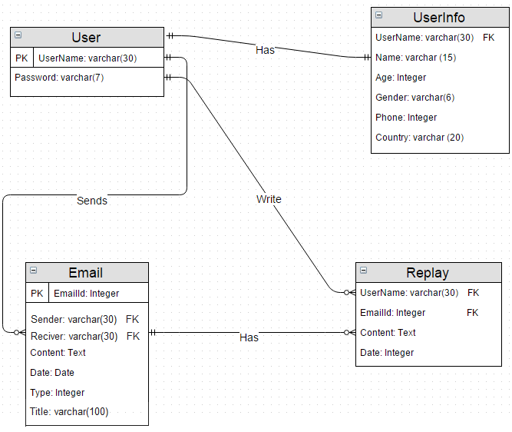

***From MySQL Workbench***

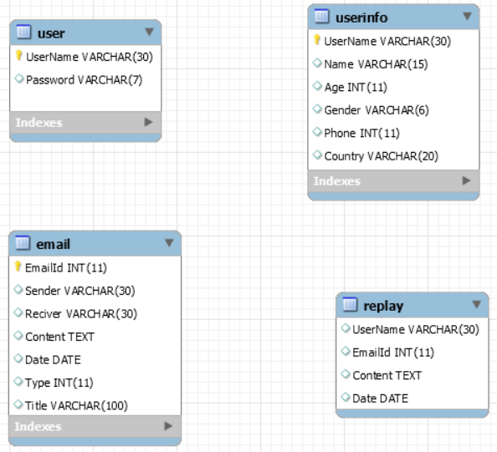

***User manual***

* Log in page

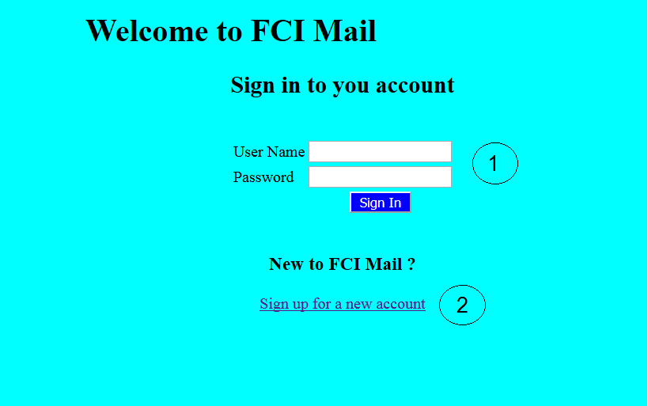

1. Log in with your registered user
2. Sign up for a new user

* Sign up page

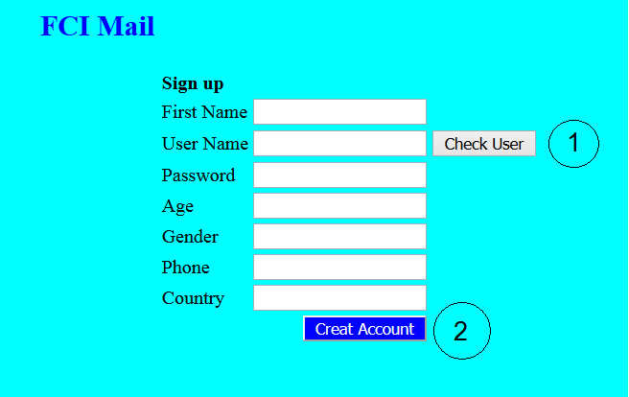

1. Check if the user name is new or already exicted
2. To create the new valid account

* Home Page (After successful login)

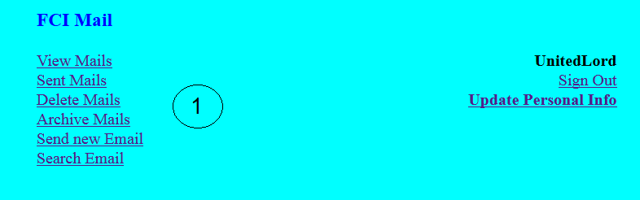

1. Links to our site functions (view received mails, view sent mails, Delete received mails, Archive received mails, Send new mail, Search for a specific mail)

* View Mails Page

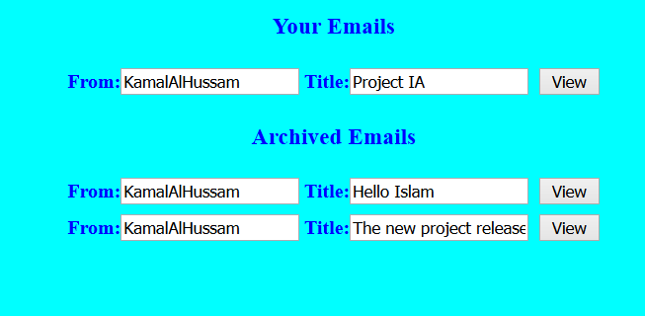

* Click on view of the first mail will result to

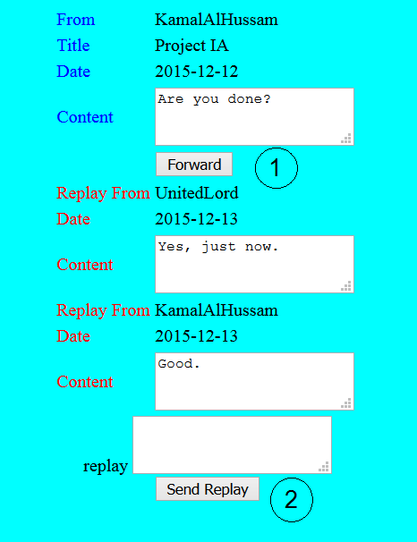

1. Forward that email to other user
2. Write a replay and send it on that email

* Click on Forward will result to

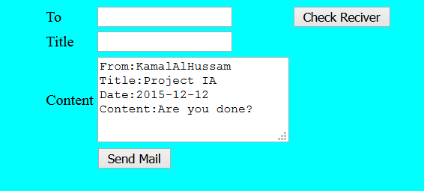

* The content is initially written like this from the site, the user can change or add any text he wants
* Sent Mails Page

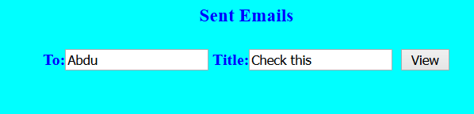

* Delete Mails Page

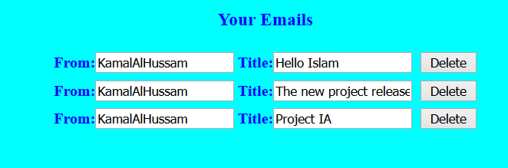

* Archive Mails Page

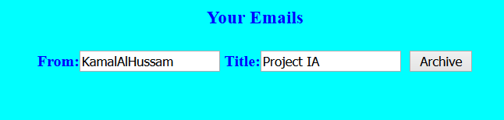

* Send New Mail Page

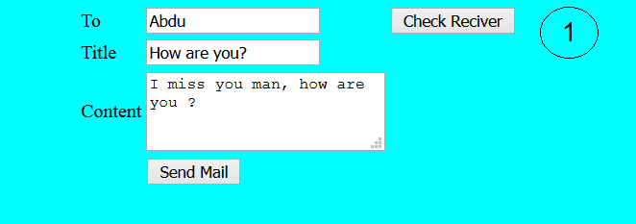

1. Check if the user excited, after clicking on (if user exicted)

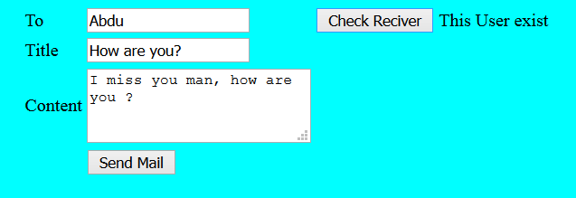

* 1. If not excited

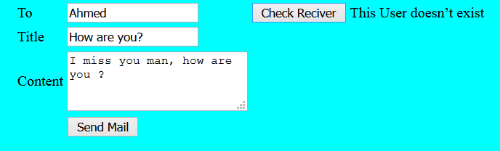

* Search for Mails page

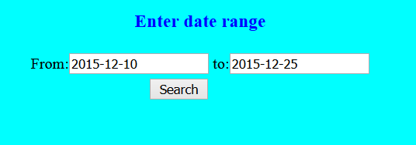

* After clicking search, the result is

